RESOLUTION NO.__________

RE: CERTIFICATE OF APPROPRIATENESS UNDER THE
PROVISIONS OF THE ACT OF THE PENNSYLVANIA
LEGISLATURE 1961, JUNE 13, P.L. 282 (53
SECTION 8004) AND BETHLEHEM ORDINANCE NO.
3952 AS AMENDED.

WHEREAS, it is proposed to install a new stairway at the rear of building at
401-405 E. 4th St.
.

NOW, THEREFORE, BE IT RESOLVED by the Council of the City of Bethlehem that a Certificate of Appropriateness is hereby granted for the work.

Sponsored by: (s)

(s)

ADOPTED BY COUNCIL THIS DAY OF

(s)
President of Council

ATTEST:

(s)
City Clerk

HISTORIC CONSERVATION COMMISSION

CASE # 400 – It is proposed to install a new stairway at the rear of the building at 401-405 E. 4th St.
OWNER/APPLICANT: Kalavathi Shunnugam

The Commission upon motion by Mr. Roeder and seconded by Mr. Evans adopted the proposal that City Council issue a Certificate of Appropriateness for the proposed work described herein:

- The proposal to install a new stairway at the rear of the building at 3rd floor turret at 401-405 E. 4th St. was presented by Kalavathi Shunnugam.

- The new stairs have already been built in wood and are located behind 405 and 403 E. 4th St. and between the rear of the buildings and garages that are located on the north property line. The open yard space appears to be about 30’ deep (in N-S direction) and 60’ wide.

- The wood stairs must be 36” wide and have closed risers. Two horizontal wood elements with three spaces between the elements and the treads will be used to close the risers.

- The stair guards must have top and bottom wood rails with 1-1/2”-2” square balusters mounted between the rails. The balusters must be spaced no more than 4” apart to meet code.

- The handrails may be round wood or metal and must meet code. Metal handrails are recommended.

- The wood used to construct the exit stair may be pressure-treated lumber, cedar, or redwood. After 6 months the wood is to be stained.

- Fasteners used in building the stair must be weatherproof (stainless steel or hot dipped galvanized).

- The installation of a new window and cornice molding on the turret was tabled for additional information.

- The proposed work was unanimously approved.

CU: cu

By: 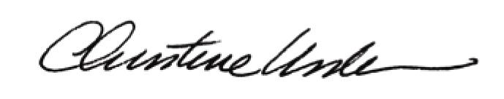

Date of Meeting: January 23, 2012 Title: Historic Officer

